## ASSIGNMENT (2-09-2005)

Submitted by: Srividya Arul Raju

Roll number: 23KQ5A0206

1. **len() :**

Returns length of all the String Value.

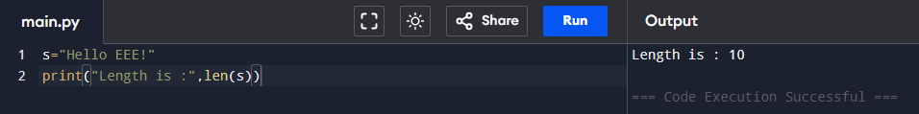

1. **.lower():**

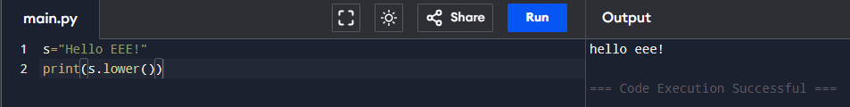Converts all Charecters into lower.

1. .**upper():**

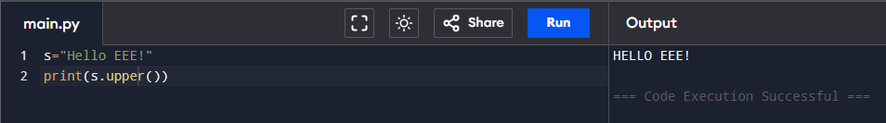Converts all Characters into Upper.

1. **.capatalize()** :

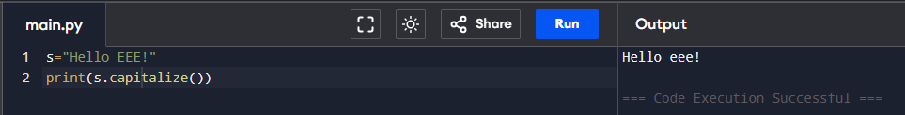It Capatalize first Character of given word.

1. **.Title() :**

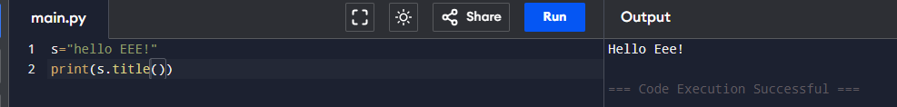Capitalizes the first letter of each word.

1. **.replaceStrip()** :

Removes leading and trailing whitespace.

1.** 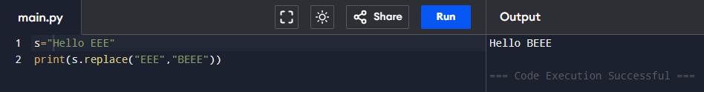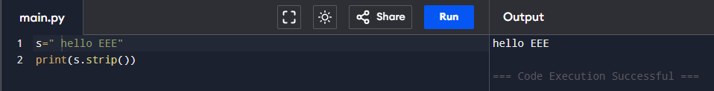.replace(old,new)**:  
   Replaces occurrences of a substring.
2. **.find(sub**) :

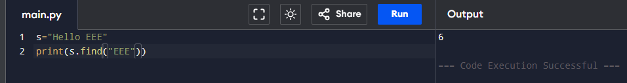Returns the index of first occurrence of sub, or -1 if not found.

1. **.index(sub)**:

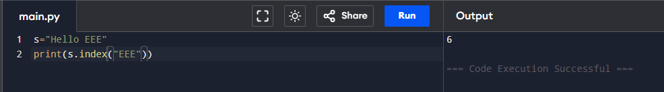Same as find() but raises an error if not found.

1. 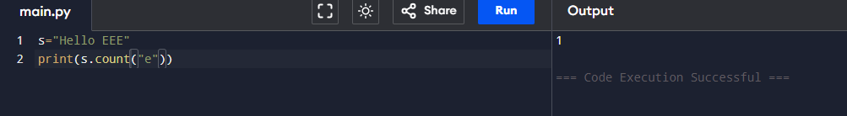 **.cont(sub)**:

11. **.Split determiter():**

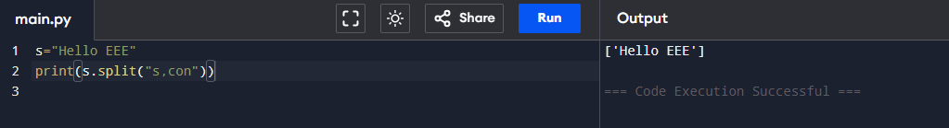Splits the string into a list.

12. **.join(iterable):**

Joins elements of a list into a string.

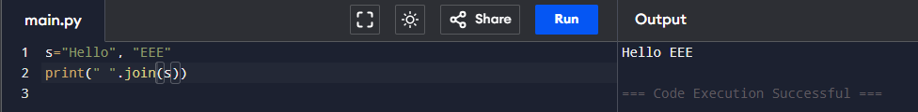

13. **.startswith(prefix)**

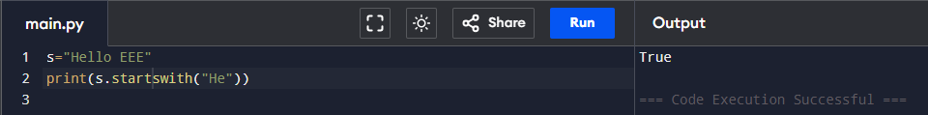Checks if string starts with a substring.

14. **.endswith(suffix)**

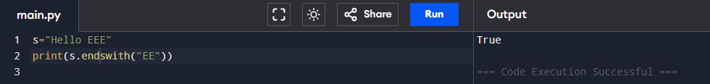Checks if string ends with a substring.

15. **.isalpha()**

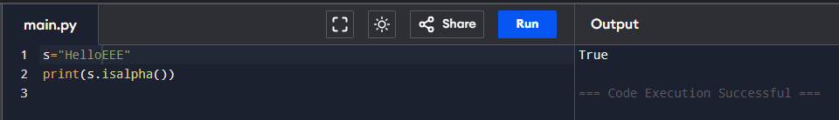Checks if all characters are alphabetic.

16. **.isdigit()**

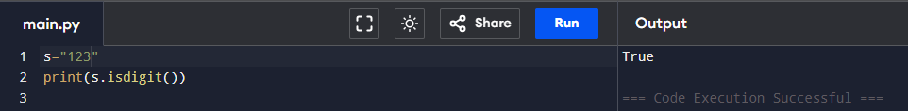Checks if all characters are digits.

17. **.isalnum()**

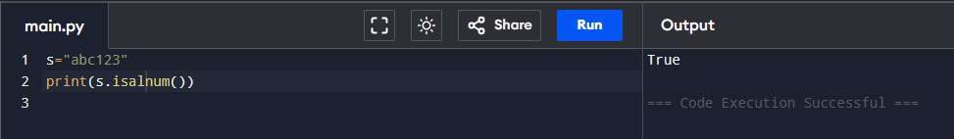Checks if all characters are alphanumeric.

18. **.swapcase()**

Swaps lowercase to uppercase and vice versa.

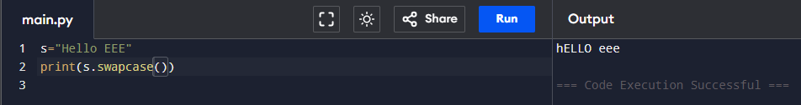19. **.zfill(width)**

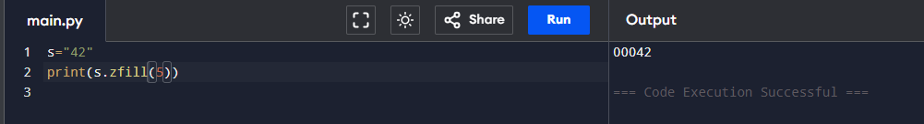Pads string on the left with zeros.

20. **.format()**

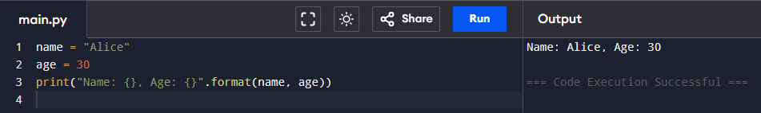Inserts variables into a string (old way).